Tilki Kitap Tanıtım Bülteni
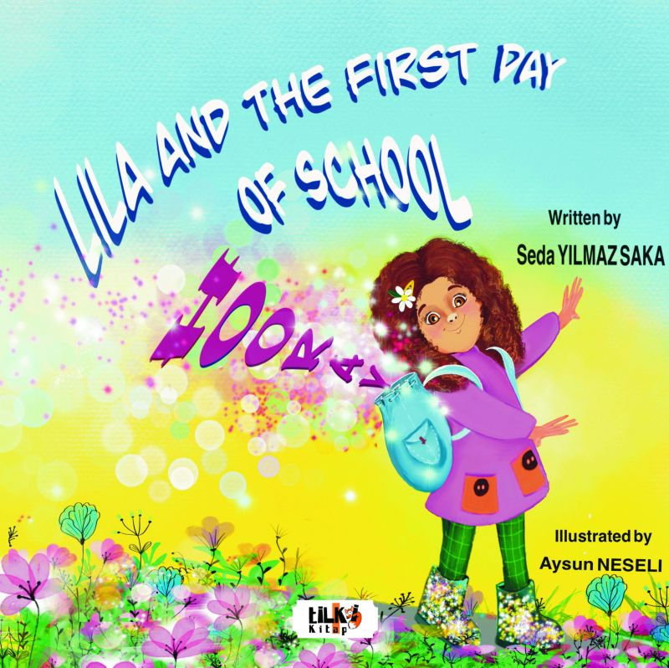 | Eser Adı: Lila and the First Day of School HOORAY  Yazar Adı: Seda Yılmaz Saka  Cilt Bilgisi: TEL DİKİŞ  Kitap Dili: Türkçe  Eser Tipi: Orjinal  İç Sayfa: 1. HAMUR CMYK 80  Kapak: BRISTOL TEL DİKİŞ 230  Yan Kapak: YOK  Selefon Türü: MAT SELEFON  Basım Tarihi: 2023  Sayfa Sayısı: 36  Kitap Boyutları: 220 X 220 mm  ISBN No: 9786256433151  Etiket Fiyatı: 470,00 TL  Editör Görevlisi: Fahri Ercan  Son Okumacı: Dr. Hakan Özkütükçü  Mizanpajcı: Yasemin Er  Kapak Grafikeri: Yasemin Er  ISBN Görevlisi: Yusuf Efe Civlez
Kitap Tanıtım Yazısı : (Arka Kapak)

Lila is a little pretty girl. She loves sunny and funny days. It's time to wake up for the first day of school. Oops ! Lila is a bit nervous New friends, new adventures and many new things Let's read and follow her on exciting journey About the writer Seda Yılmaz Saka is a lecturer and educator in a university and has been teaching English for 14 years. She is also the mother of two daughters called Lara and Lidya. She enjoys reading, translating, travelling, learning new things and drinking too much coffee. She always inspires and encourages her daughters, other children and her students to 'dream big'. She loves hearing from her readers too! She's grateful for every book review.
Kitabın detay sayfasına buradan ulaşabilirsiniz :
https://tilkikitap.com/kitaplar/kitap-baski-seda-yilmaz-saka-lila-and-the-first-day-of-school-hooray-3288.html
Tilki Kitap



