Verno Kitap Tanıtım Bülteni
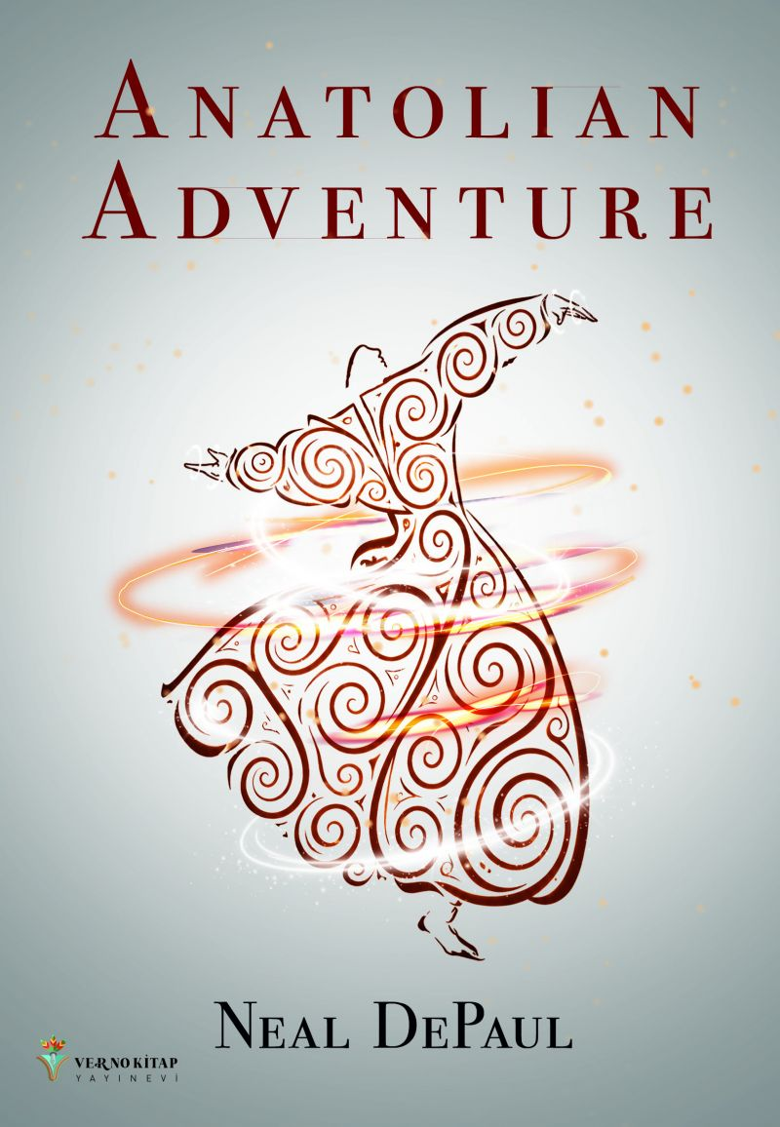 | Eser Adı: Anatolian Adventure  Yazar Adı: Neal DePaul  Cilt Bilgisi: AMERİKAN  Kitap Dili: Türkçe  Eser Tipi: Orjinal  İç Sayfa: 2. HAMUR SB 60  Kapak: BRISTOL AMERİKAN 230  Yan Kapak: YOK  Selefon Türü: MAT SELEFON  Basım Tarihi: 2026  Sayfa Sayısı: 369  Kitap Boyutları: 135 X 195 mm  ISBN No: 9786259287874  Etiket Fiyatı: 710,00 TL  Kurucu: Emrah Çelik  Yayın Danışmanı: Emre Demir  Editör Görevlisi: Yaşar Kürüm  Mizanpajcı: Baran Ekber  Kapak Grafikeri: Tekin Parmaksız  ISBN Görevlisi: Yusuf Efe Civlez
Kitap Tanıtım Yazısı : (Arka Kapak)

In the summer of 1979, Neal and Libby DePaul chose Istanbul for their honeymoon—because they were never ordinary people.
In the final days of Ramadan, inside the Blue Mosque with ten thousand of the faithful, a small, unremarkable man catches their eye. He places one hand over his chest. He speaks just a few words: We will meet again.
It is not a coincidence.
As the young couple immerses themselves in the ancient layers of Turkey — navigating Istanbul's grand bazaars, crossing the Bosphorus between continents, teaching at an all-girls school on the Aegean coast, hiking the volcanic slopes of Mount Ararat — a shadow follows them. Aras Ananaki speaks every language, never tires, arrives without warning, and leaves without explanation. He brings gifts too precious to own and remembers places that no living man should know.
Who is he? And why has he chosen them?
Anatolian Adventure is at once a love story, a teacher's memoir, and a doorway into humanity's oldest secret. Woven between the vivid rhythms of expatriate life — language school disasters, mosquito-plagued honeymoon nights, a classroom full of razor-sharp Turkish girls, friendships forged over endless plates of mezeler — lies a far stranger and more ancient story. One that stretches from the cradle of civilization to the far edge of the galaxy.
Because the gods have always been among us. They simply went by different names.

Part memoir, part travelogue, part science fiction, Anatolian Adventure is the story of two young Americans who went to Turkey to teach — and came home forever changed by something they still cannot fully explain.

Kitabın detay sayfasına buradan ulaşabilirsiniz :
https://tilkikitap.com/kitaplar/neal-depaul-anatolian-adventure-5893.html
Verno Kitap



